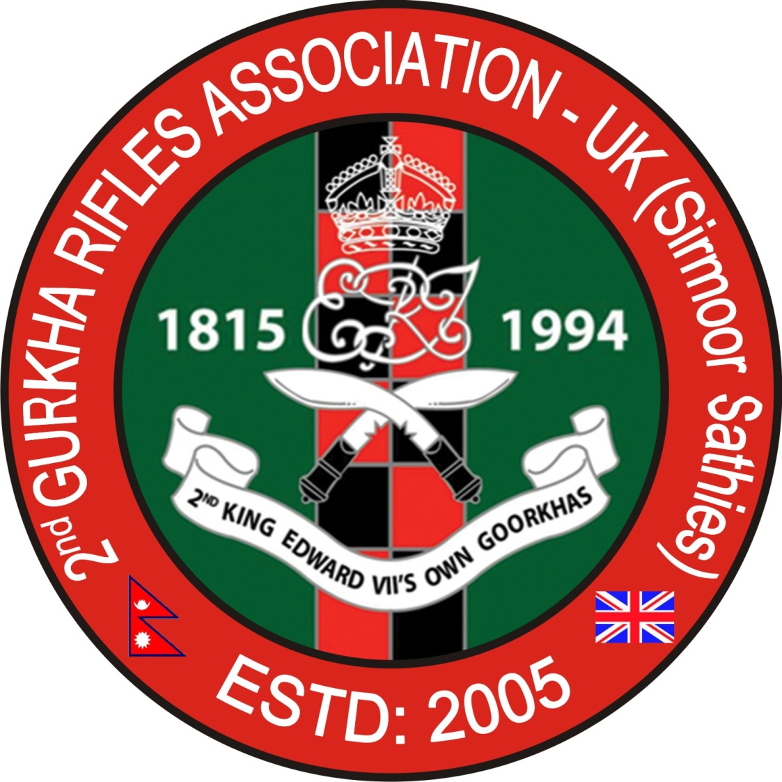
2GR ASSOCIATION-UK (SIRMOOR SATHIES) – 168TH DELHI DAY-CUM-210TH REGIMENTS ANNUAL REUNION PARTY - POST REPORT SUNDAY, 14 SEPTEMBER 2025

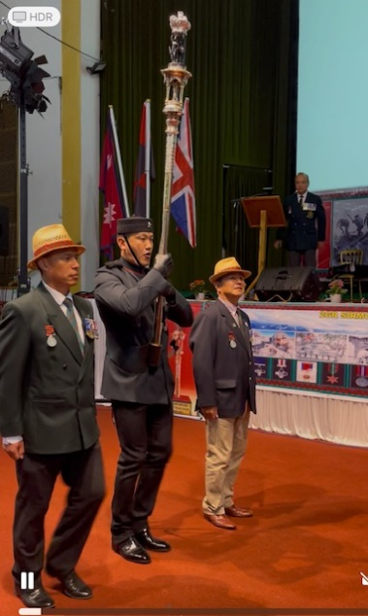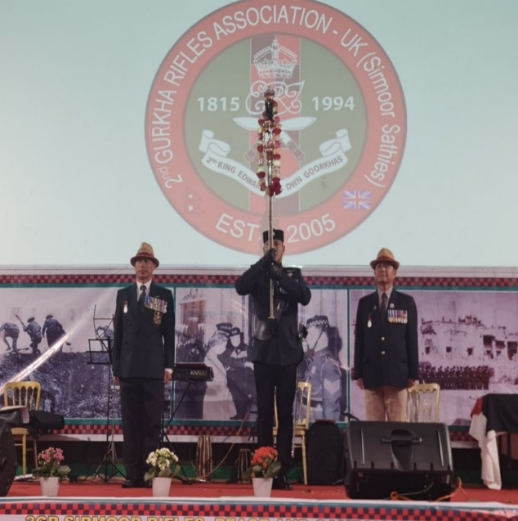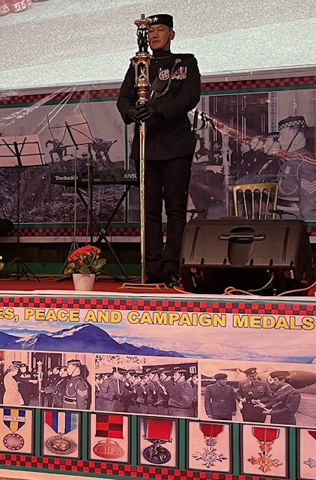
The QT team led by Captain Sojit Gauchan 1RGR Escorted by WO2 Ishowr Ale and
Cpl Dal Gurung from 2GR Sirmoor Sathis on Delhi Day 14 Sep 2025 at Empire Hall Aldershot in UK

- BACKGROUND: The 2GR Simoor Rifle Regiments Raised in April 1815 and sieged of Delhi Dur bar was a decisive conflict of the Indian Rebellion in 1857 and results British Victory. The Regiment awarded First Delhi Day Battle honour and the Queen’s Truncheon famously known as ‘Nishani Mai’ (QT) amongst Gurkhas by Late Queen Victoria for the 2nd King Edward VII’s Own Gurkha Rifles (also known as Sirmoor Rifles). Since, then our Regiments celebrating Delhi Day and Regiment Annual Reunion Party on 14 September each year until Regiment disbanded on 30 June 1994. Due to its unwavering loyalty during the 1857 Indian Mutiny the regiment was awarded the Queen’s Truncheon (QT). Even to this day, the Sirmoor Regiment Officers and soldiers proudly pay their respect to Nishani Mai (QT) each year celebrations and the practice is now followed by the A (Delhi) Company 1st Royal Gurkha Rifles (1RGR) and C (Tamadu) Company 2nd Royal Gurkha Rifles (2RGR) also RGR New Recruits Attestation parade each year. The 2004 changes in Gurkhas’ Terms and Condition of Service (GTACOS) allowed Gurkhas to resettle in the UK. More than 3000+2GR Sirmoories settled down in the UK but some stayed in Nepal hence the 2ND Gurkha Rifles Association-UK (Sirmoor Rifles) was branched into three main Groups: Sirmoor Club UK (Known as British officers’ club), Sirmoor Sathies UK (Sirmooris living in UK) and Sirmoor Club Nepal (Sirmooris living in Nepal). The Sirmoor Club Nepal founded by Maj Lachimiprasad Gurung MVO, BEM in September 1996 and 2nd Gurkha Rifles Association-UK (Sirmoor Sathies) was founded by Major (GCO) Lalbahadur Gurung officially formed in March 2014 at Aldershot in UK (but was unofficially formed in Sep 2005). Since 2GR Sirmoor Sathies UK formed in March 2014, We, 2GR Sirmoor Club-UK and Sirmoor Sathies-UK jointly celebrating Delhi Day and Regiment Annual Party and Funded by SRA Trust until Last year Delhi on 14 Sep 2024. The SRA trust was closed on June 2024 and from this year, we will celebrated Delhi Day and Regiment Birth Day with Self-Funding Basis. The 2GR Sirmoor Sathies-UK Celebrated 168th Delhi Day in Five Different Locations across the UK as follows;

- Main Central Celebration 2GR Sirmoor Club UK and 2GR Sirmoor Sathies Living around the London Area with QT at Empire Hall Aldershot – Approx 240 Attended Led by Capt Raju Gurung and Sgt Krisna Gurung.
- Messing Type Celebration 2GR Sirmoories Living North at Catterick – Approx 16 Members Attended Led by Capt Bhaktabahadur Thapa MVO.
- Messing Type Celebration 2GR Sirmoories Living in Midland area at Nuneaton – Approx 46 Attended Led by Lt Rambahadur Rana MBE.
- Messing Type Celebration 2GR Sirmoories Living in Kent area at Folkestone – Approx 34 Attended Led by Capt Bishnubahadur Singh.
- Messing Type Celebration 2GR Sirmoories Living in South West and Wales at Swindon – Approx 66 Attended Led by Major Guptaman Gurung MVO, MBE Ex-GM 1RGR.

- AIM: The UK Sirmoor Sathies’ aim remained no change to keep alive the Regiments history plus unwavering true friendship, uniquely vibrant esprit-de-corps, ethos and camaraderie in amongst the three Sirmoor Rifle Associations (SRAS) members. This is achieved by annually celebrating unique battle honours, ie Delhi Day (1857), Tigris (1916), and Tamandu (1945) on the 14 September each year or on the nearest weekend mainly to pay respect to the Queen’s Truncheon at Regiments Annual Reunion Day. However, this year 168th Deli Day on Sunday, 14 September 2025 was celebrated centrally at Empire Hall Aldershot with Nissani Mai (QT) which Led by Captain Sorjit Gauchan 1RGR and Sirmoor Sathis provided 2 x in-home escort WO2 Ishowr Ale Magar and Cpl Dalbahadur Gurung. The 168th Delhi Day celebrations 2025 with QT was very successful without any incident. The Chief Guest was Lt General Sir Peter Duffell KCB CBE MC and Lady Annie Duffell Mem Saheb. More than 240 + Sirmooris, Guests, Senior officers including their Families Successfully celebrated 5 Different Locations and read out Battle honours History on the Sunday, 14 September 2025 by by Maj Nigel Wylie Carrick MBE (Tigris), Capt Krishnabahadur Gurung (Tamandu) and Capt Umeshkumar Pun MVO (Delhi) followed by 2 minutes silents to pay tribute to our Forefathers, brothers and sisters those who lost their lives in War and peace.
- Financial breakdown Central Celebration at Aldershot: The 2GR Association-UK (Sirmoor Sathis) successfully celebrated Delhi Day 2025. Total members Entry Fee Contribution (£4800) and Donation for Dohari Singers (£400). Total income £5200 and Expenditure £5159 thus giving the Sathis a total balance is £41 which credited Sathis Account. The Income and Expenditure details are as shown below.
a. Income:
- Officers and Members Entry Ticket £20 each x 240 = £4800, Total income is - £4800:00
- Gift Donation from Members for the Lok Dohari Songa Team Ms Anupa and Yubaraj Magar - £400:00
Total Income: = £5200:00
b. Expenditure:
- Food for the 240 Members paid - £3840:00
- Public Address System (PA) - £550:00
- Queen’s Truncheon Garland and Loss Flowers - £67:00
- The cost for the Queen’s Truncheon (QT) Escort car and Fuel - £180:00
- Empire Hall Aldershot Security Hire Cost - £122:00
- Payments to Lok Dohari Songa Team Ms Anupa Roka and Yubaraj Magar - £400:00
Total Expenditure is: - £5159:00
b. Income £5200 – Expenditure - £5159 = Total Balance is £41 which will be Forwarded to Next year. Note: The Transportation cost for the QT was £180 including Fuel which subsidised by Sirmoor Sathis central fund which forwarded by Last year Celebration. The Sathis Central Fund will be use only QT Transportation and fuel cost.
- In conclusion: For making the 168th Delhi Day Celebrations-Cum-210th Annual Regimental Reunion party was a huge success. As a 2GR Association-UK (Sirmoor Sathis) Event Coordinator I, Capt Raju Gurung and Members would like to extend our heartfelt thanks to all our Chief Guest, Special Guest, 5 Area Representatives officers plus the kind Volunteers of Central Committee (not forgetting the ever cheerful and helpful Sirmoor ladies) including Lali Culture team Cpl Tanka Sherchan, WO2 Pahalsing Thapa and Mrs Chhabi Pun who had worked tirelessly on the annual DDay Events Since established in 2014 making the day a huge success each year. All the Members of 2GR Association-UK (Sirmoor Sathies) wish to convey our profuse thanks and their wholehearted support for the DDay 2025 would not have been such a huge success and memorable one! The kind-hearted helpers are:

- Maj Nigel Wylie Carrick MBE (Hon Sec of Sirmoor Club UK (SCUK), who has very kindly been arranged the presence of the Queen’s Truncheon (QT) or (Nishani Mai) in liaison with the CO, GM, Adjt and RSM of the 1RGR/2RGR Battalion of Shorncliffe in the past 12 years.
- Lt Col J Jeffcoat CO 1RGR, Major Babindra Gurung MVO, GM 1RGR, WO1 Hemraj Rana Magar RSM 1RGR. The Queen’s Truncheon (QT) Captain was Captain Sojit Gauchan Saheb 1RGR who led the QT Team with an outstanding performance in very short Notice and impressed all 2GR Sirmoor Rifles Members including our in-home QT Escort WO2 Ishowr Ale Magar and Cpl Dal Gurung.
- Capt Ramprasad Gurung H&S officer and LO from Shorncliffe Barracks for QT Last 12 years.
- Empire Hall Managing Director Mr Puran and Narayan Giri provided free Venue and Excellent Food.

The 2nd Gurkha Rifles Association-UK (Sirmoor Sathies) enthusiastically look forward to celebrate 169th Delhi Day-Cum-Regiment Reunion party with QT together with Sirmoor Club UK on Sunday, 13 September 2026 same venue at Aldershot Empire Hall with self-funding Basis. I attached below the Delhi day 2025 Celebrations Photos and short clips for your copies. A picture is worth a Thousand Words.
Thank you. Jai Lali Paltan!
Yours Sincerely,
(Signed)
Captain (Retd) Raju Gurung
Event Coordinator 2GR Association-UK (Sirmoor Sathies)
Mobile: 07735413073
E-mail: rupgurung1976@gmail.com
Website: www.2ndgoorkhas.com

Dated: 15 October 2025

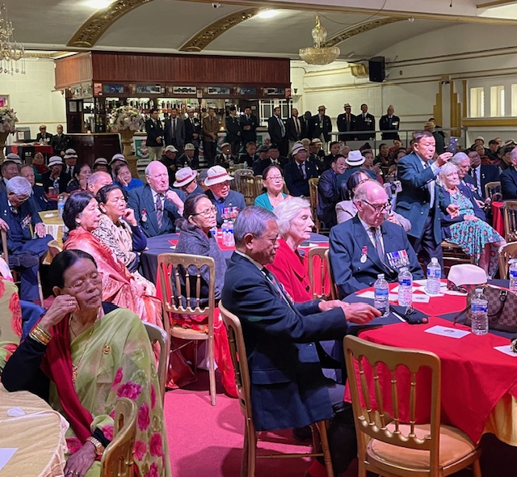
Photonews of 2GR Sirmoor Sathies-UK Members photograph with Chief Guest, Lt General Sir Peter Duffell KCB CBE MC at Delhi Day on 14 Sep 2025 at Empire Hall Aldershot in UK.
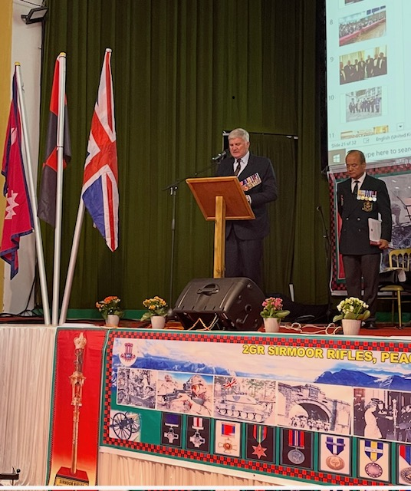 Brig Ian Rigden OBE President SRA UK Giving his 168th Delhi Day Speech
on 14 Sep 2025 at Empire Hall Aldershot in UK
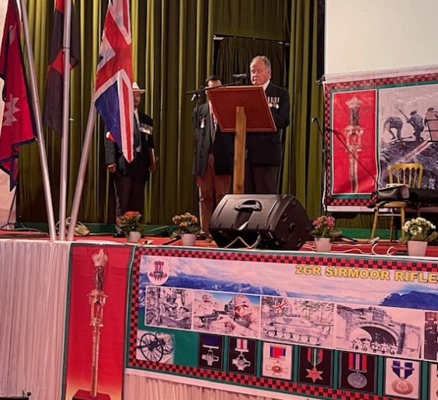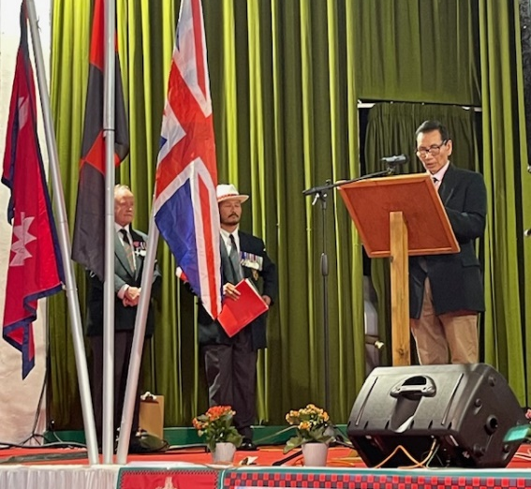
Major Nigel Wylie Carrick MBE, Hon Secretary of SRA UK Reading Tigris Day (1916) and Capt Krishna Gurung Reading Tamandu Day (1945) Battle honour history on 14 Sep 2025
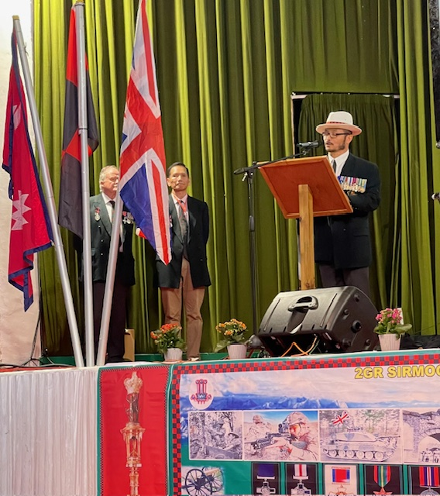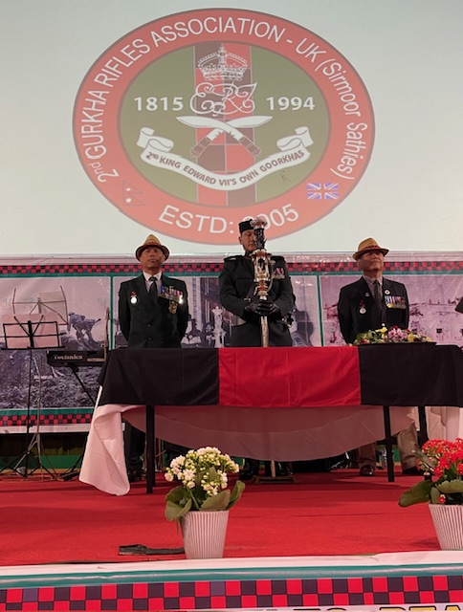
Capt Umesh Pun MVO Reading Delhi Day (1857) Battle honour history and Capt Sojit Gauchan
1RGR and WO2 Ishwor Ale, Cpl Dal Gurung Ex 2GR Escorted QT at DDay on 14 Sep 2025
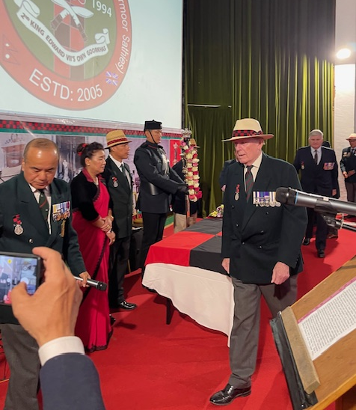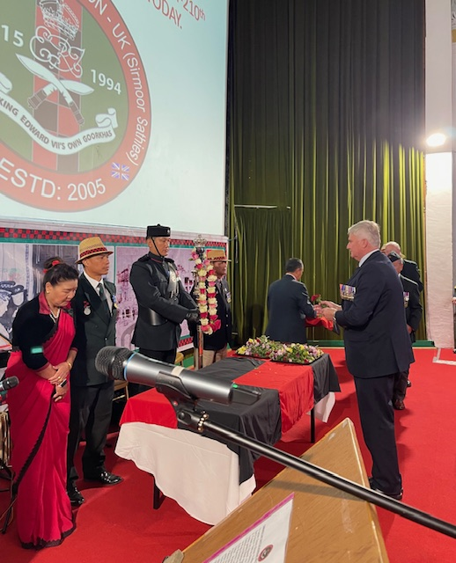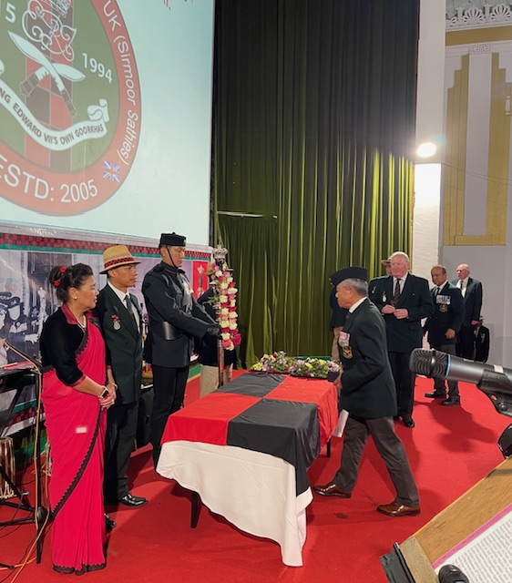
Chief Guest, Lt General Sir Peter Duffell KCB CBE MC, Special Guest Brig Ian Rigden OBE and Major Lalbahadur Gurung MBE (First Gurkha Major 1RGR) paying Respect QT at DDay on 14 Sep 2025.

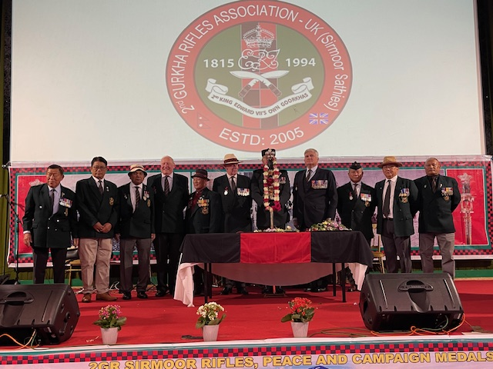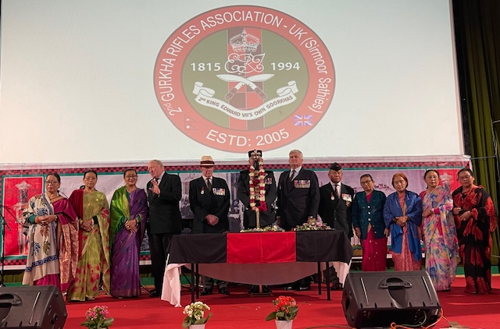
2GR Members and Family paying Respect to QT at DDay 14 Sep 2025 & photograph with Senior officers

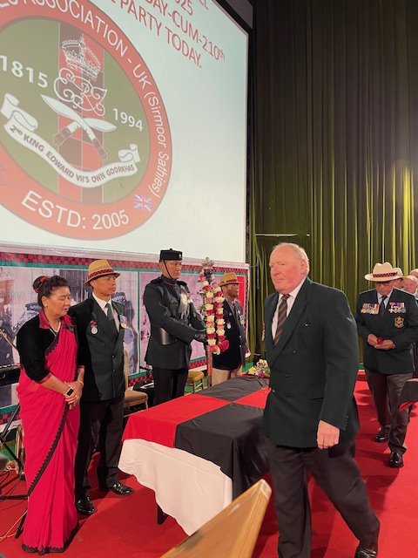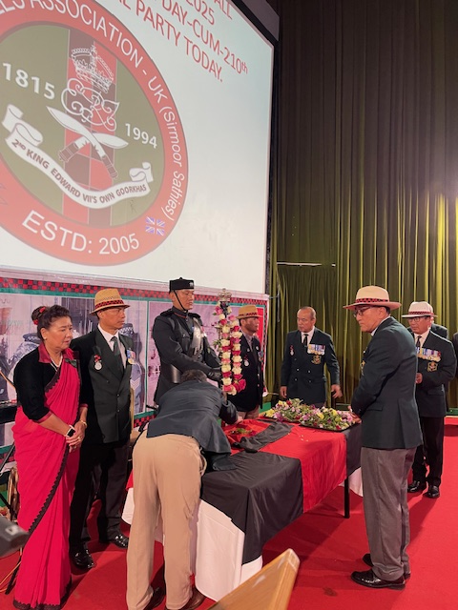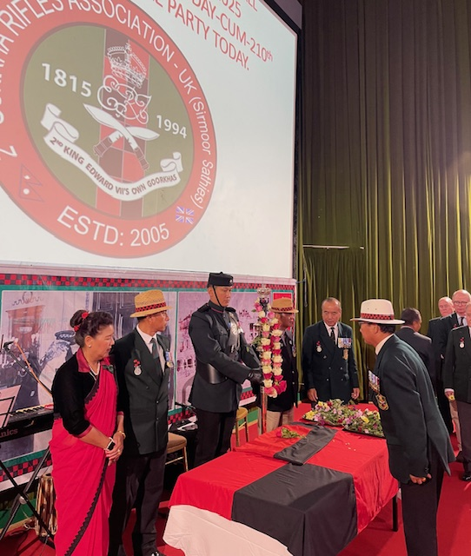
Colonel William Shuttlewood OBE, Chairman of SRA UK, Major Rambahadur Gurung MBE and
Major Narkaji Gurung paying Respect to QT at DDay on 14 Sep 2025 at Empire Hall Aldershot in UK
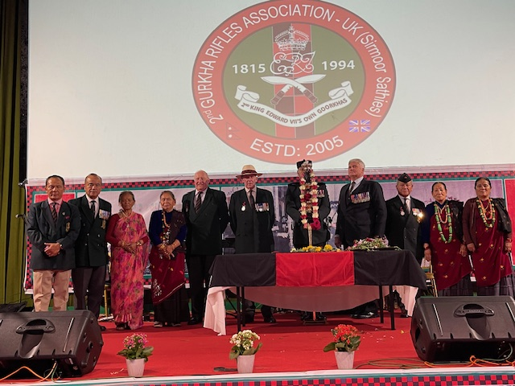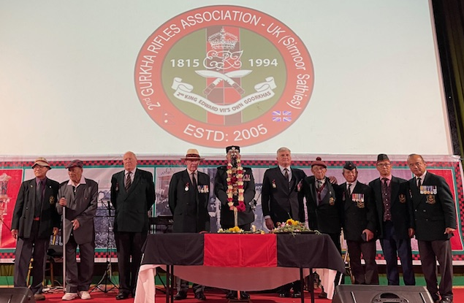
2GR Members and Family paying Respect to QT at DDay 14 Sep 2025 & photograph with Senior officers
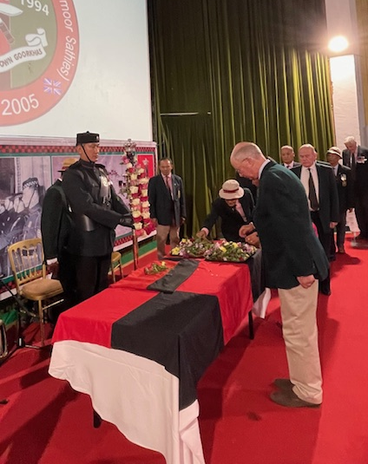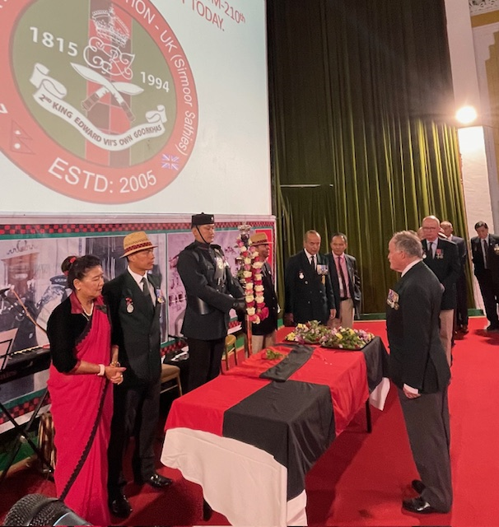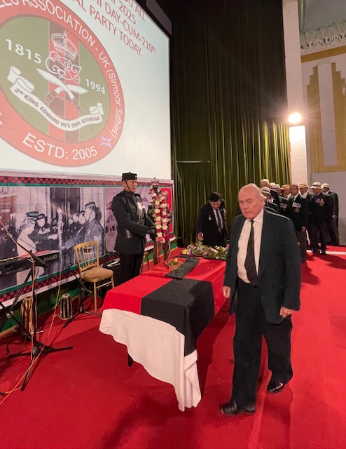
Colonel Nick Hinton MBE, Major Nigel Wylie Carrick MBE and Brig Nigel Haynes CBE paying Respect
to QT at DDay 14 Sep 2025 at Empire Hall Aldershot in UK

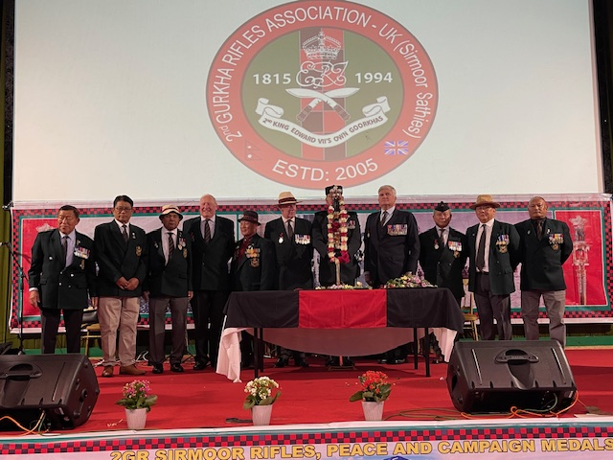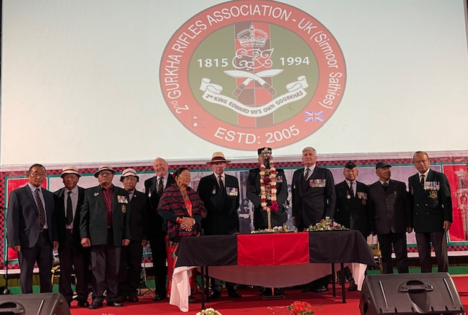
2GR Members and Family paying Respect to QT at DDay 14 Sep 2025 & photograph with Senior officers
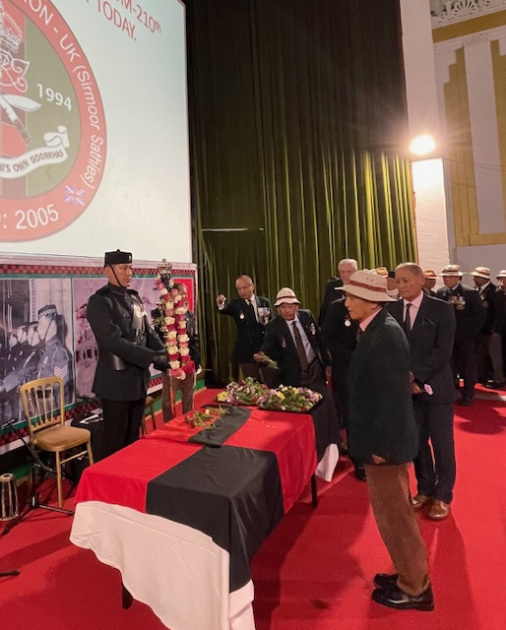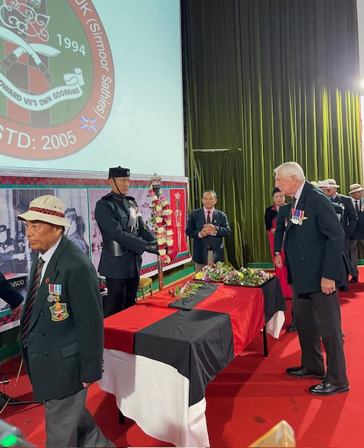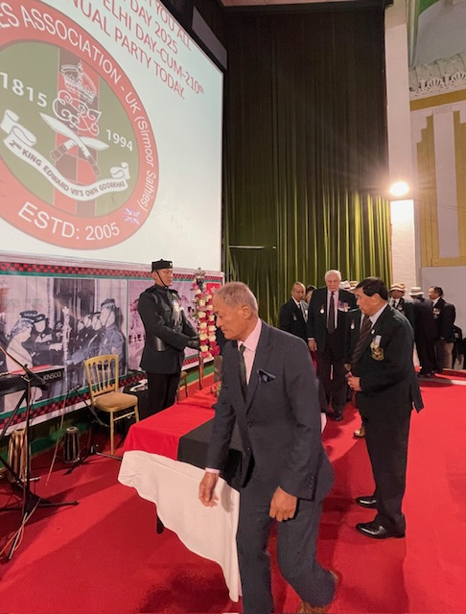
Major Krishnakumar Ale BEM, Major David Thomas MBE and Capt Jiwan Gurung paying Respect
to QT at DDay 14 Sep 2025 at Empire Hall Aldershot in UK
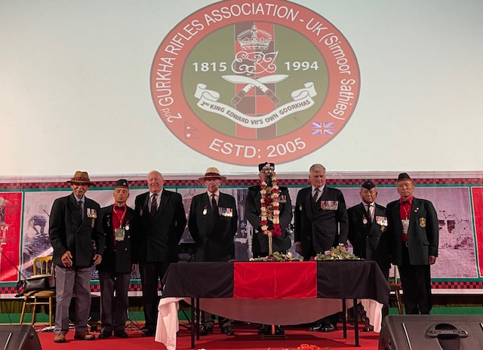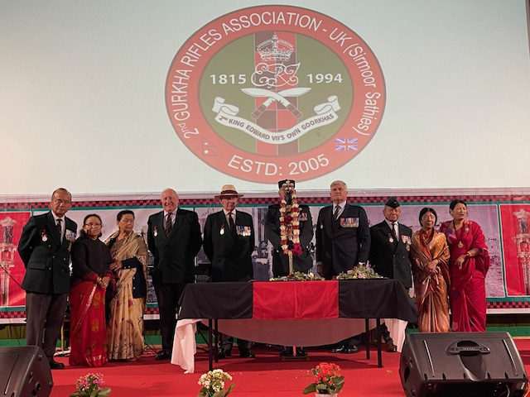
2GR Members and Family paying Respect to QT at DDay 14 Sep 2025 & photograph with Senior officers
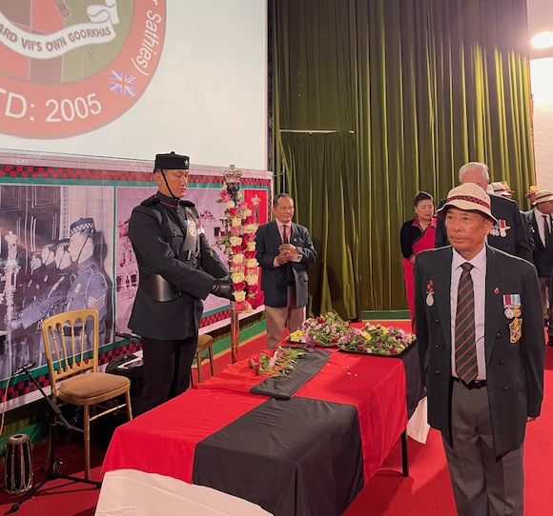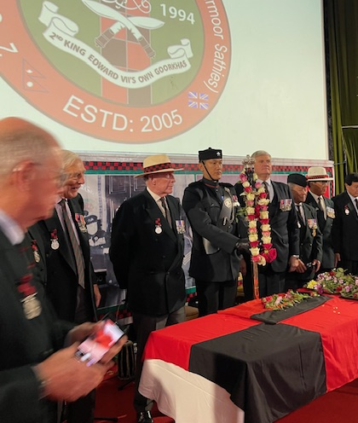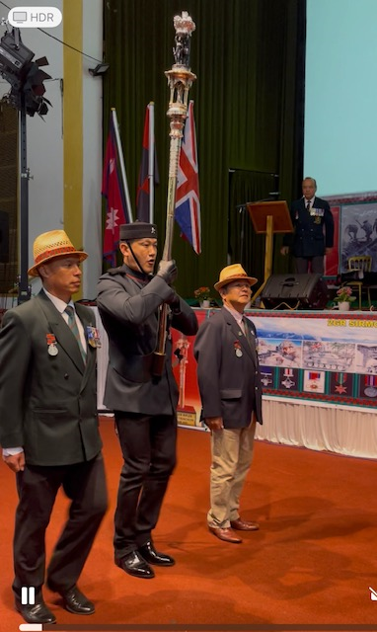
Capt Ramkaji Gurung and Members paying Respect to QT at DDay 14 Sep 2025 at Aldershot in UK

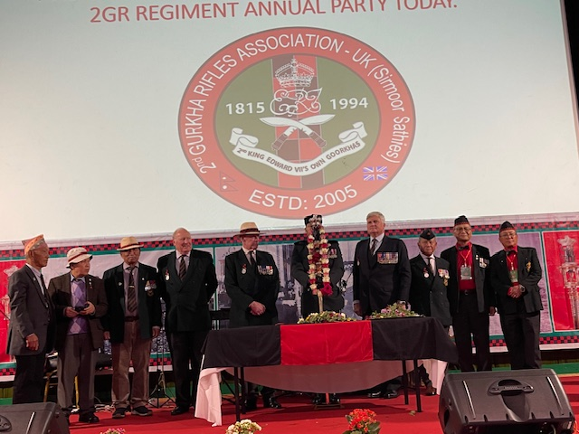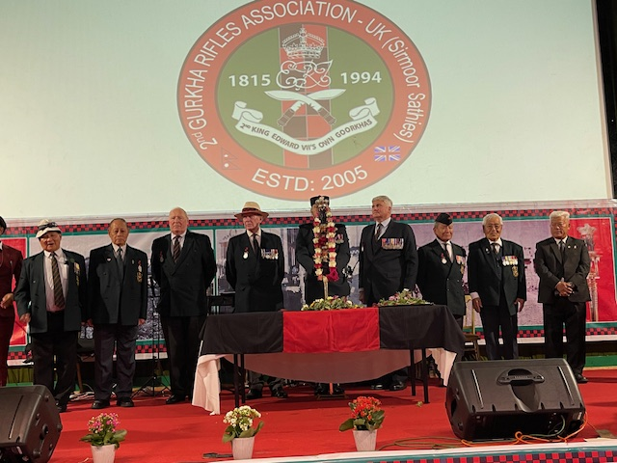
2GR Members and Family paying Respect to QT at DDay 14 Sep 2025 & photograph with Senior officers

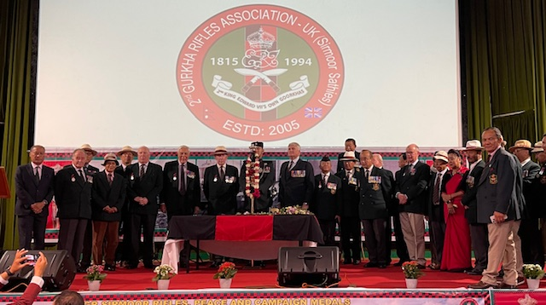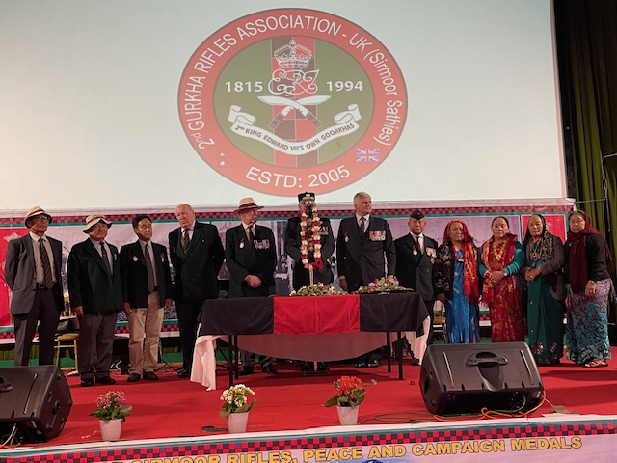
2GR Members and Family paying Respect to QT at DDay 14 Sep 2025 & photograph with Senior officers

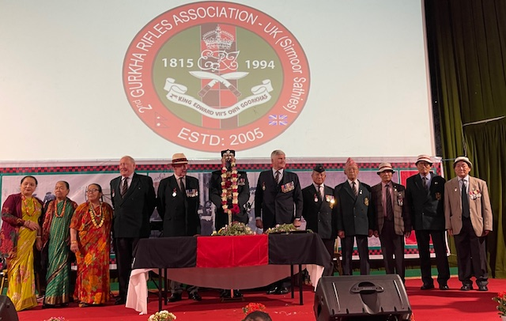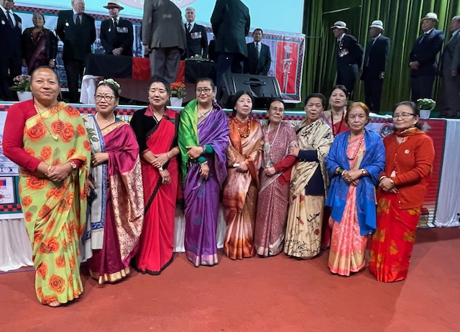
2GR Members Lali Culture Team and Family paid Respect to QT and photograph with Senior officers.

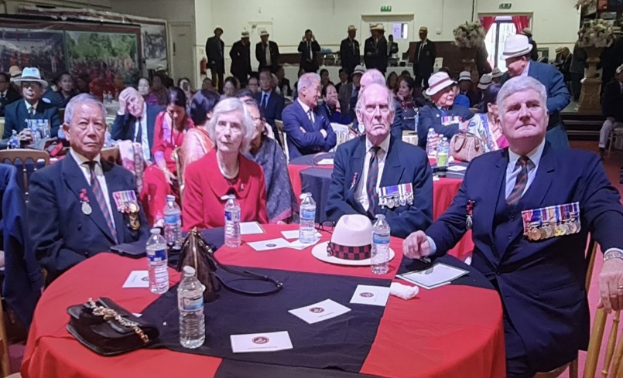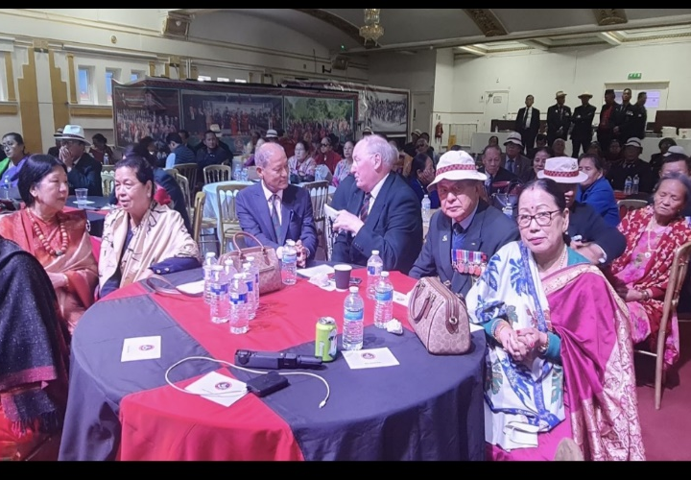
The Chief Guest Lt General Sir Peter Duffell KCB CBE MC and Lady Annie Duffell Mem Saheb, SRA UK President Brig Ian Rigden OBE and Senior Officers and Members enjoying DDay 2025.

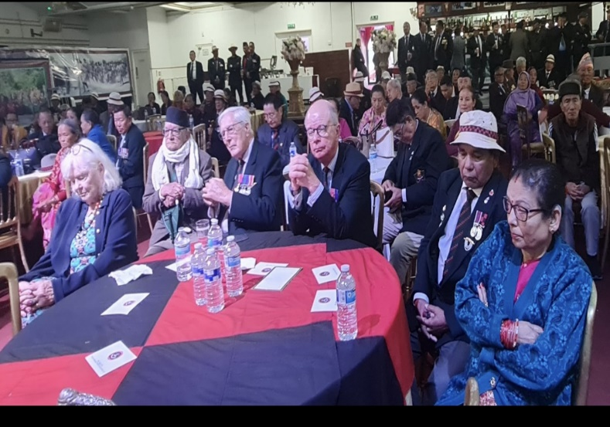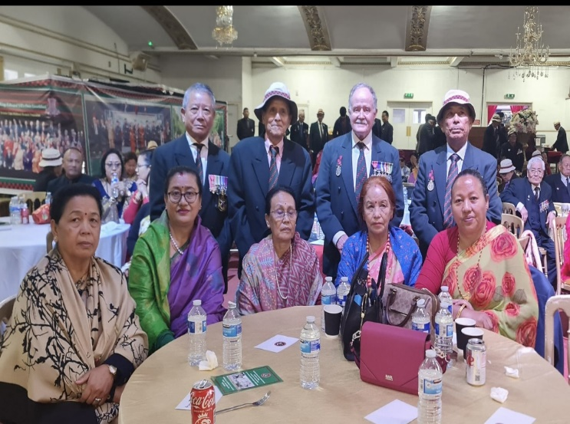
2GR Sirmoori Senior Officers & Members and Family Enjoying DDay Celebrations on Sunday 14 Sep 2025

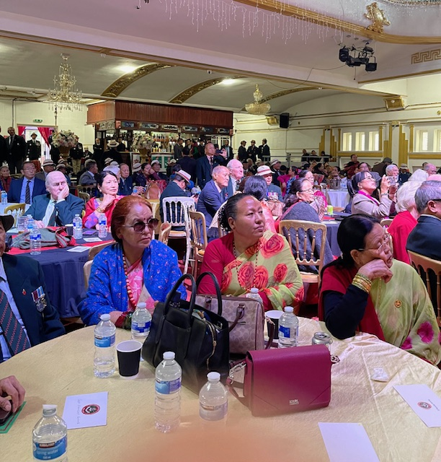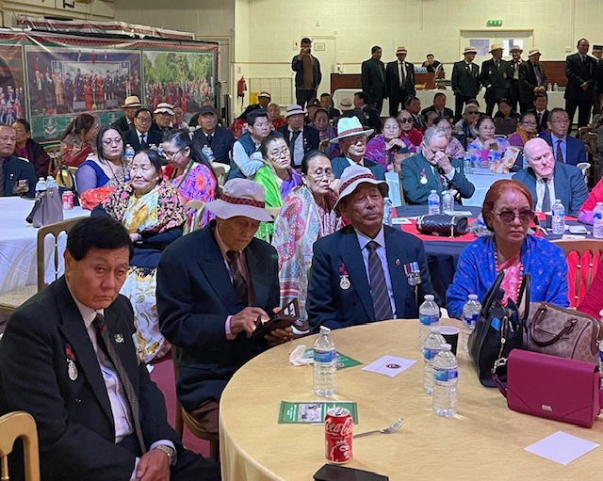
2GR Sirmoori Senior Officers, Members and Family Enjoying DDay Celebrations on Sun 14 Sep 2025

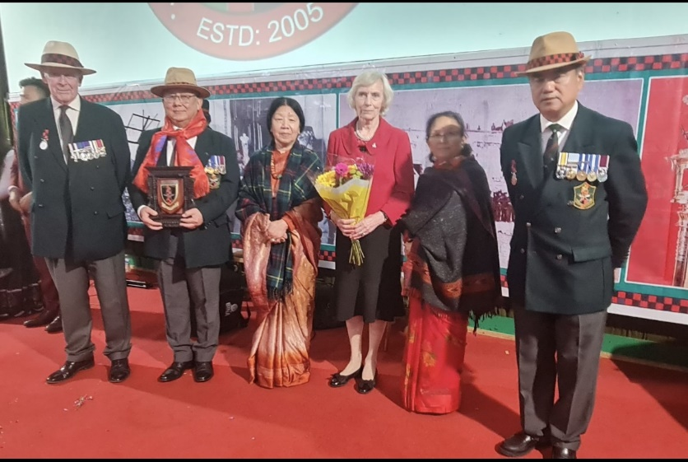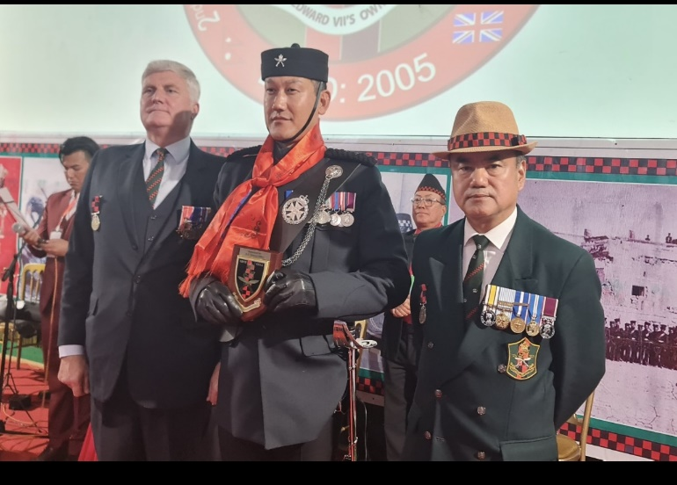
The Chief Guest Lt General Sir Peter Duffell KCB CBE MC and Lady Annie Duffell Mem Saheb presented Token of Love to Vice Chairman Capt and Mrs Shamsher Gurung and SRA UK President Brig Ian Rigden Presented Token of Love to QT Comd Captain Sojit Gauchan 1RGR on DDay 14 Sep 2025.
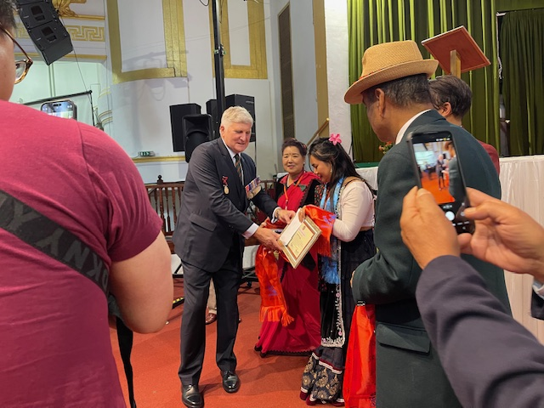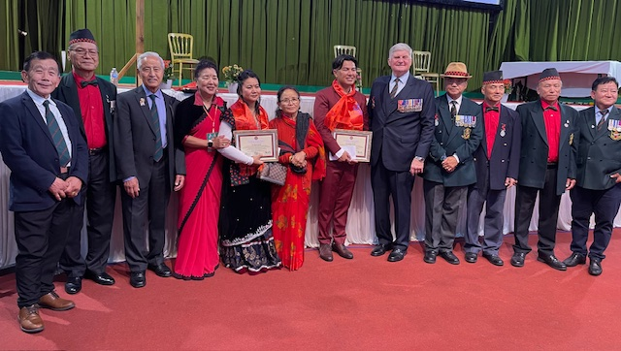
SRA UK President Brig Ian Rigden OBE Presented Token of Love to Entertainment Team on DDay 14 Sep 2025.

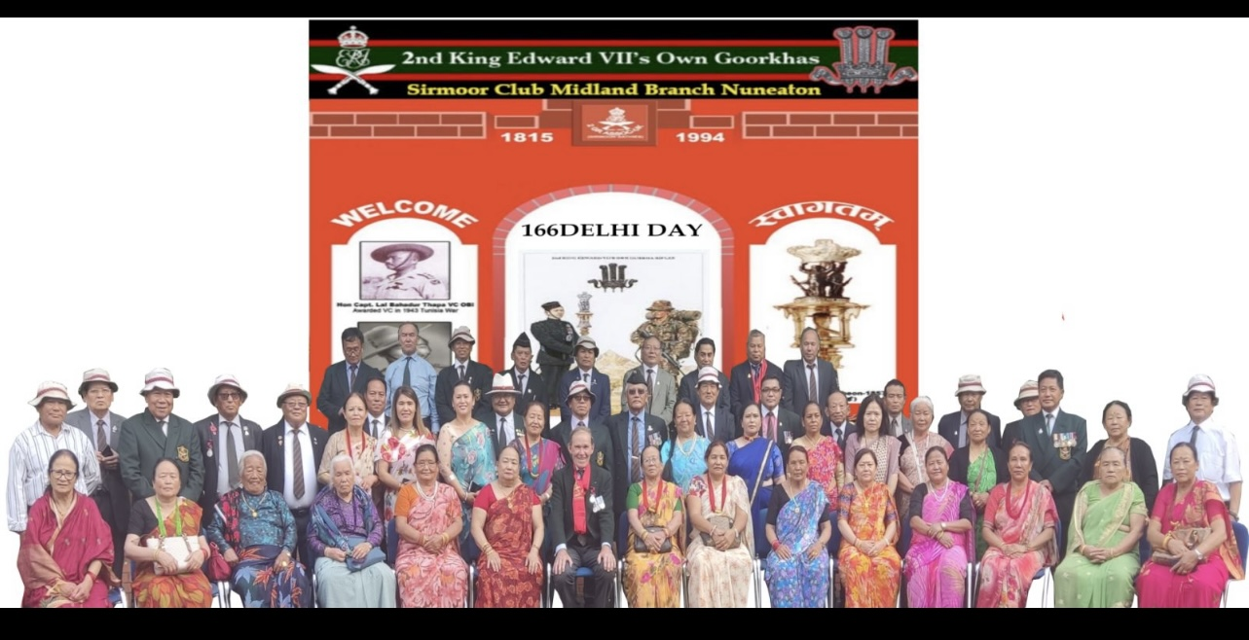

2GR Sirmoor Sathies-UK Living Midland Area Celebrated DDAY on 14 Sep 2025 at Nuneaton.
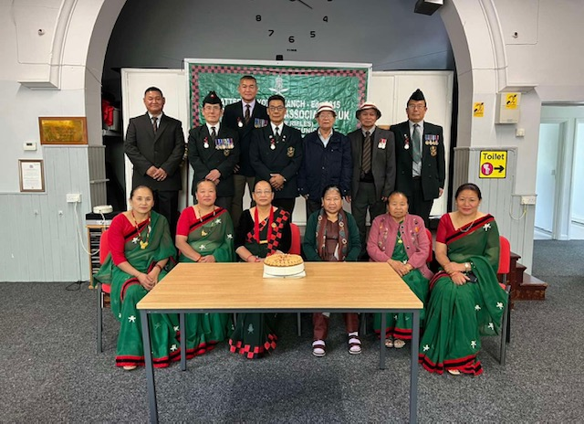
2GR Sirmoor Sathies-UK Living at North Area Celebrated DDAY on 13 Sep 2025 at Catterick.
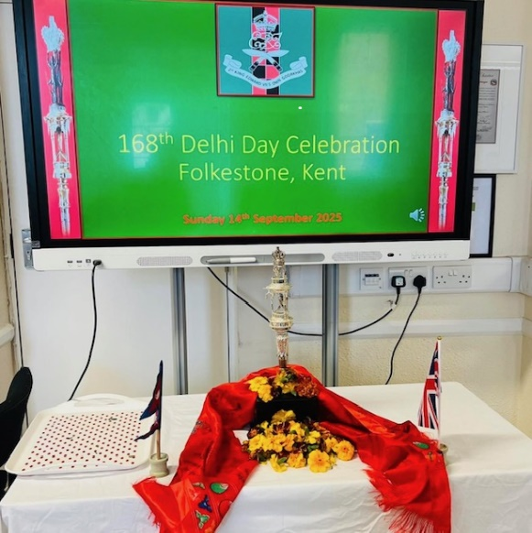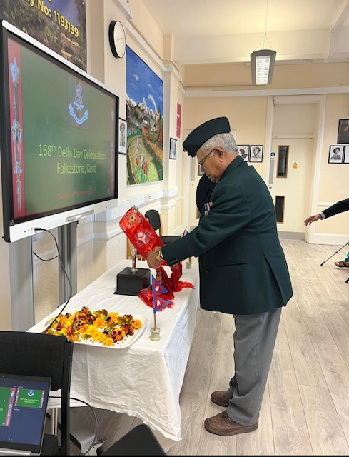
2GR SIRMOOR SATHIES-UK KENT BRANCH CHIEF GUEST MAJ DEBBDR PUN PAYING RESPECT
TO QT ON DDAY CELEBRATION PHOTONEWS 14 SEP 2025
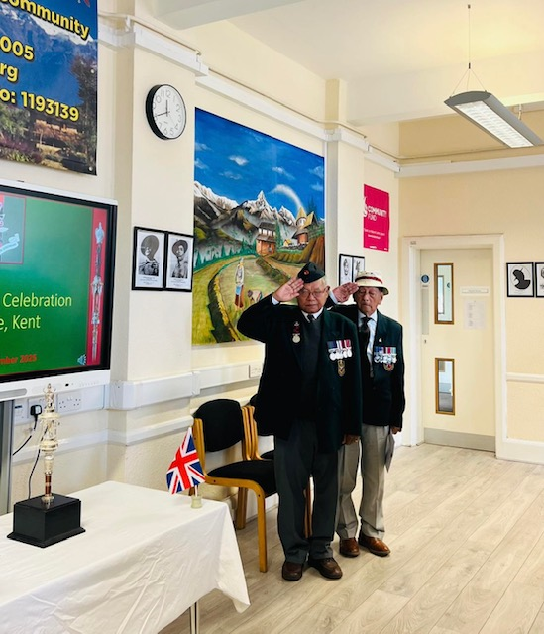 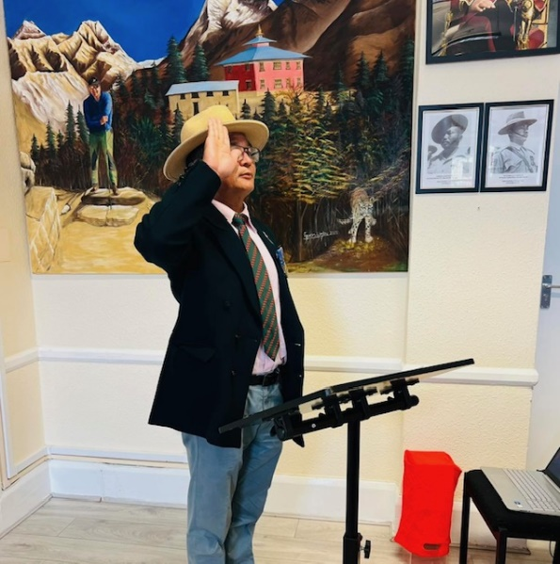 2GR SIRMOOR SATHIES-UK KENT BRANCH MAJ DEBBDR PUN AND CAPT BISHNU SINGH
PAYING RESPECT TO QT ON DDAY CELEBRATION PHOTONEWS 14 SEP 2025
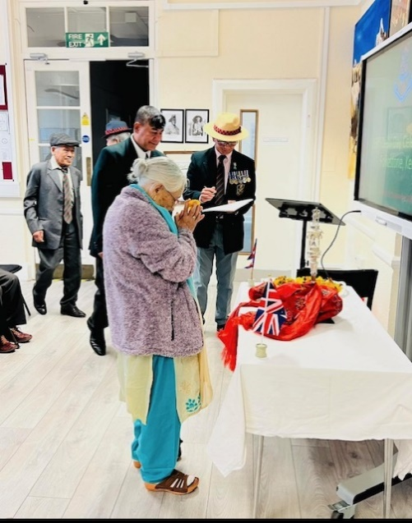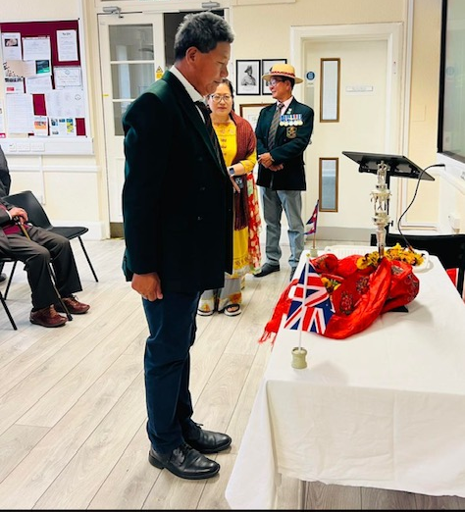
2GR Sirmoor Sathies-UK Living Kent Area Paying Respect to QT on 14 Sep 2025 at Folkestone.
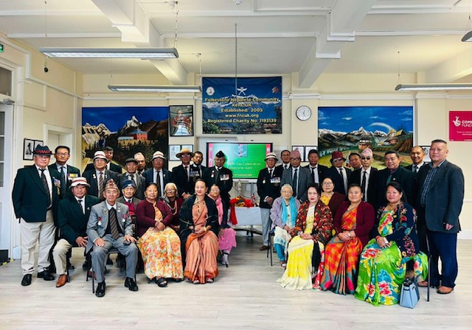
2GR SIRMOOR SATHIES-UK KENT BRANCH DDAY CELEBRATION GROUP PHOTONEWS 14 SEP 2025

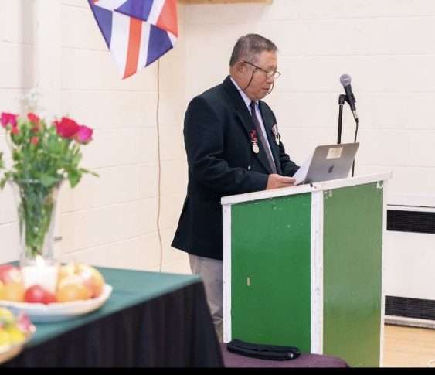n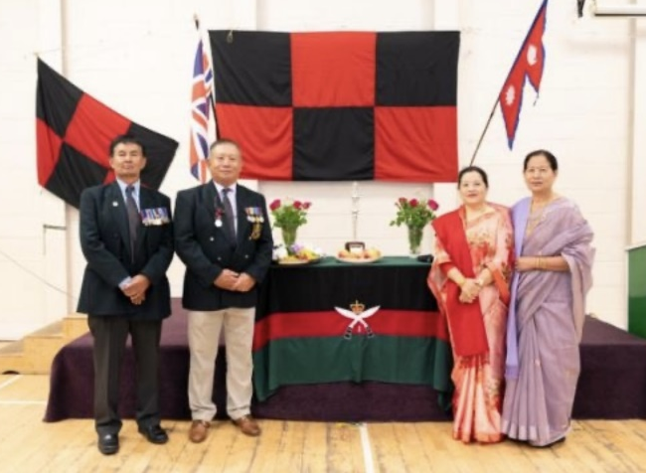
2GR Sirmoor Sathies-UK Living South West and Wales Area Celebrated DDAY on 14 Sep 2025 at Swindon and Chief Guest Captain Devraj Gurung Reading out DDay Battle history.
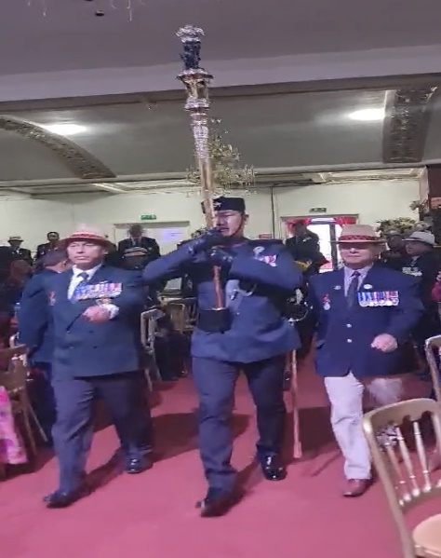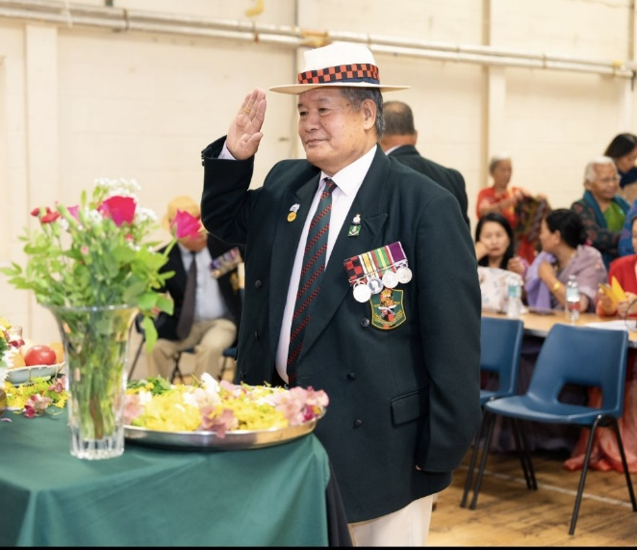
2GR SIRMOOR SATHIES-UK SWINDON BRANCH DDAY CELEBRATION GP PHOTONEWS 14 SEP 2025

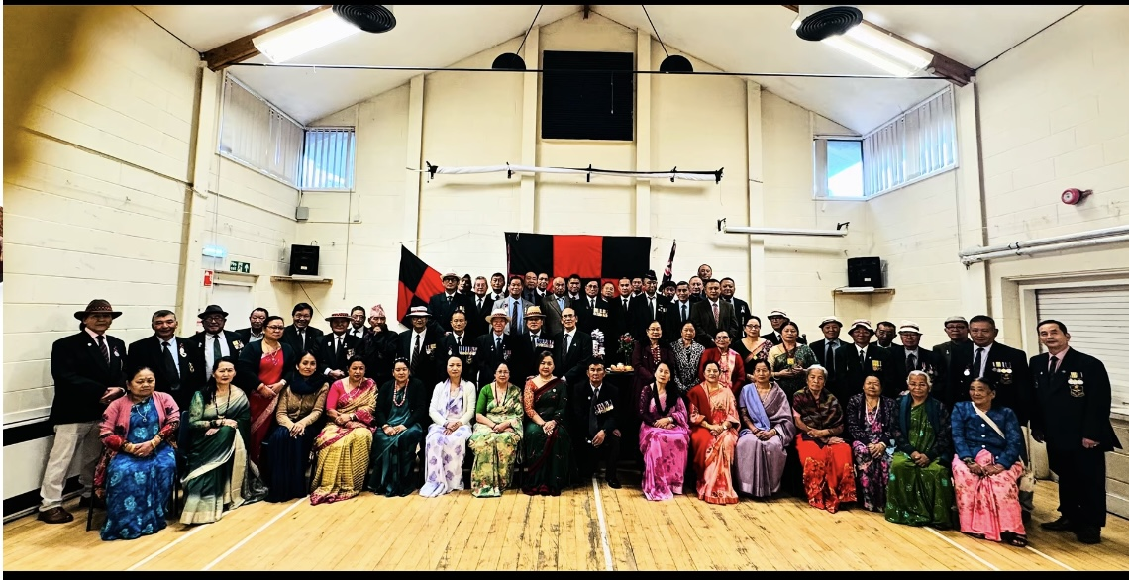
2GR SIRMOOR SATHIES-UK SWINDON BRANCH DDAY CELEBRATION GP PHOTONEWS 14 SEP 2025

