Colonel Denis Wood, veteran of action in Malaya and Borneo and devoted chronicler of Gurkha regiments
He and his close friend, Field Marshal Sir John Chapple, helped raise the profile of the Gurkhas by moving the Gurkha Museum to Winchester
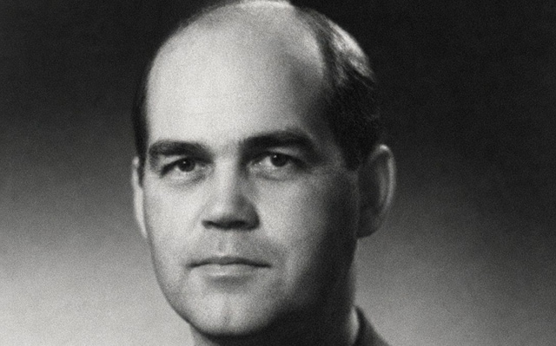
Wood: a great gift for friendship Credit: Courtesy of family
​Colonel Denis Wood, who has died aged 98, was a distinguished officer of the 2nd King Edward VII’s Own Goorkhas (The Sirmoor Rifles), as well as an assiduous regimental historian and archivist and a co-founder of the Gurkha Museum.
The son of Colonel Roland Wood of the Royal Northumberland Fusiliers and his wife Margaret, née Baikie, Denis Roland Wood was born in Newcastle upon Tyne on August 19 1927 and educated at Dame Allan’s School, Newcastle, and Windermere School.
In 1944 he enlisted as an Indian Army Cadet in the Queen’s Royal Regiment (West Surrey), and after basic training at Maidstone he embarked for India the following year.
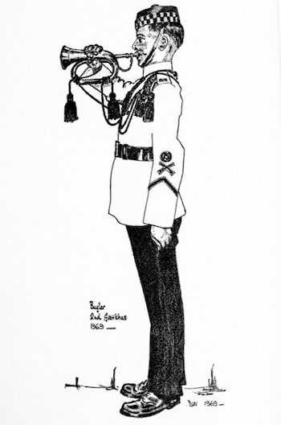
Regimental bugler, 2nd Goorkhas
Wood was gazetted to the ​Royal Northumberland Fusiliers after six months at the Officer Training School in Bangalore. But he was immediately seconded to the 2nd Goorkhas, as a result, he said later, of an inspiring talk with a senior 2nd Goorkhas officer at the railway station. From 1946 to 1948 he served with the 1st Battalion at Dehradun, Bombay and Poona as a company officer, company commander and quartermaster.
Advertisement
Following the disruption and confusion of Indian Independence and the transfer of his regiment from the Indian to the British Army in 1948, Wood found himself on operations in Johore during the Malayan Emergency. The Gurkhas provided much of the backbone of the 12-year campaign against the Communist terrorists. Wood served as adjutant and subsequently company commander. He was Mentioned in Despatches.
On one occasion, he was on reconnaissance in a helicopter when, after a loud “bang” from the rotor, the chopper plummeted to the ground. Wood, the pilot and a fellow passenger extracted themselves from the wreckage almost unharmed. Wood was due to host a cocktail party in Singapore that evening, commandeered another helicopter. Arriving at the party on time but still in his jungle uniform, he ordered champagne for all the guests to celebrate his narrow escape.
Attendance at Staff College, Camberley, was followed by​ a move to the War Office as a Military Intelligence Staff Officer. In 1964, he returned to the 1st Battalion in Hong Kong as second-in-command and deployed on three six-month operational tours in the Borneo campaign, part of the Indonesia–Malaysia Konfrontasi.
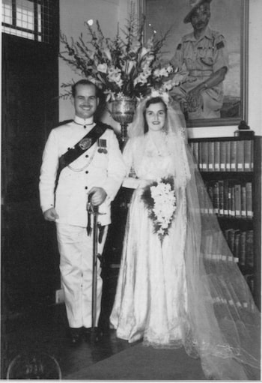
Denis Wood and his bride Christina (Chris) Flynn, Singapore 1953
What began as a minor revolt turned into a major confrontation with well-equipped, aggressive units of the Indonesian Army along an 800-mile border between Sarawak, Brunei and North Borneo (Sabah) on one side and Indonesian Borneo (Kalimantan) on the other. In a largely unreported conflict, operations were carried out in rugged, remote terrain with heavy responsibility resting on the resourcefulness of the ​company commanders on the spot.
Advertisement
Wood spent two years on the Directing Staff of the Staff College, Camberley, before assuming command of the 1st Battalion in Brunei in 1968. He was awarded the Borneo campaign medal. At the end of the year, the battalion moved to Singapore. He relinquished his command in 1970 and took up a Grade 1 staff appointment in charge of Operations and Plans at GHQ Far East.
After a spell on the Directing Staff of the Joint Services Staff College (renamed the National Defence College during his tour) he was promoted to full Colonel and appointed Colonel General Staff Defence Intelligence 2 (South and South-East Asia and the Far East). The job did not suit him, and in October 1973 he retired from the Army.
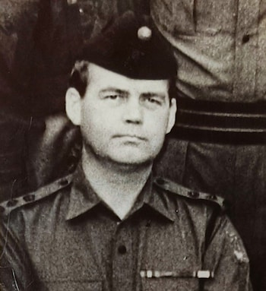
Wood as commanding officer
As a civilian, he worked for a life insurance and pensions company until he retired in August 1987. Most of his energy and enthusiasm, however, were devoted to military history. He and his close friend, Field Marshal Sir John Chapple – also a 2nd Goorkha – were the driving forces behind moving the Gurkha Museum to Winchester in 1990.
The museum was originally set up in 1973 in Queen Elizabeth Barracks at Church Crookham in Hampshire and its move to Winchester was a transformational project. It raised the profile of the Gurkhas in Britain by making their history easily accessible to the public and established a focal point for the Brigade of Gurkhas where events could be held to celebrate and perpetuate its history.
Wood brought his organisational skills and financial acumen to the project and this contributed greatly to its success and sustainability. He was chairman of Museum Trustees from 1978 to 2003 and was appointed MBE in 2002.
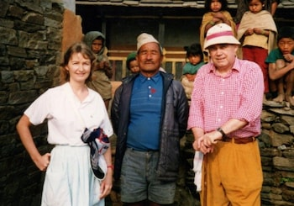
Denis Wood and his daughter, Carolyn, in Nepal with Havildar Bhanbhagta Gurung VC
He maintained a lifelong interest in his father’s regiment, the Royal Northumberland Fusiliers, and wrote numerous articles for the Indian Military Historical Society and the Military Historical Society, of which he was vice-president. He had a great gift for friendship.
In 2003 he published the fourth volume of the history of The 2nd King Edward VII’s Own Goorkhas (The Sirmoor Rifles), covering the years 1948 to 1994.
Denis Wood married, in 1953, Bridget Christina “Chris” Flynn, whom he first met when she was a nursing sister in Queen Alexandra’s Imperial Military Nursing Service. She died in 2011 and he is survived by their daughter, Carolyn, who cared for her father during the last years of his life.
Colonel Denis Wood, born August 19 1927, died June 22 2026

