
EX PURKHA KO PAURAKH 26
HQ BRITISH GURKHAS NEPAL

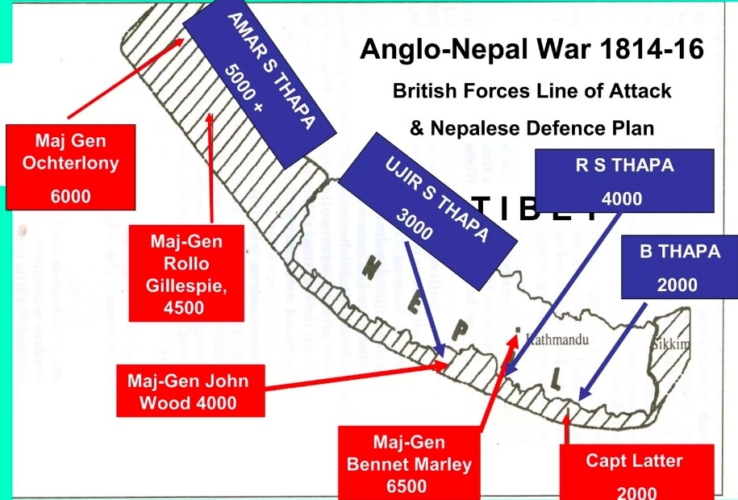

INDIA – ANGLO-NEPALESE WAR & INDIAN MUTINY
HQ BGN | Officer/ORs Development | Battlefield Study Booklet
10 – 17 May 2026
1. EXECUTIVE SUMMARY
This battlefield study examines the Anglo-Nepalese War and the Indian Mutiny, alongside key sites including the Red Fort and Taj Mahal.
The study demonstrates that:
Terrain, leadership, morale, and adaptability consistently outweigh numerical and technological superiority.
2. INTRODUCTION
This booklet supports a structured battlefield study across India, designed to enhance operational understanding, leadership judgement, and historical awareness. It links past campaigns to modern military thinking, particularly in mountain warfare, crisis response, and hybrid conflict environments.
3. ANGLO-NEPALESE WAR (1814–1816)
Narrative & Analysis
At the beginning of the nineteenth century, the Himalayan frontier was not a fixed boundary but a shifting zone of influence where ambition, geography, and misunderstanding collided. To the north stood the Kingdom of Nepal, a relatively young but rapidly expanding state forged through the unification campaigns of the Shah dynasty. To the south, the British East India Company had evolved from a commercial enterprise into a territorial power of formidable scale, steadily extending its authority across the Indian subcontinent. Inevitably, these two expansionist systems moved toward confrontation.
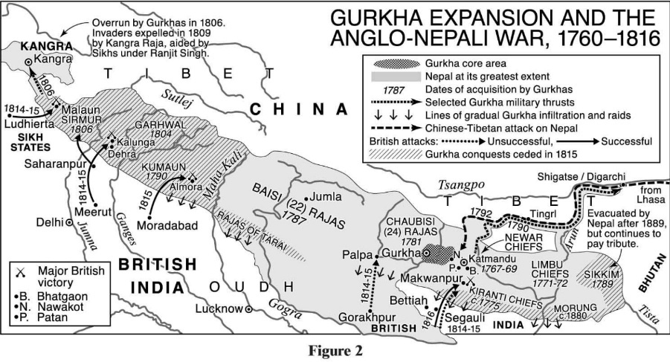
The roots of the Anglo-Nepalese War lay not in a single provocation, but in a pattern of friction that intensified over time. Nepalese expansion westward into the hill states of Kumaon and Garhwal, coupled with southward movement into the fertile plains of the Terai, brought Nepalese administrators and local commanders into frequent contact—and often conflict—with communities and territories that the British increasingly considered within their sphere of influence. These disputes were rarely clear-cut. Borders were ill-defined, maps unreliable, and authority in many frontier areas ambiguous. What might begin as a local disagreement over taxation or land rights could rapidly escalate into armed confrontation, drawing in larger formations and hardening political positions.
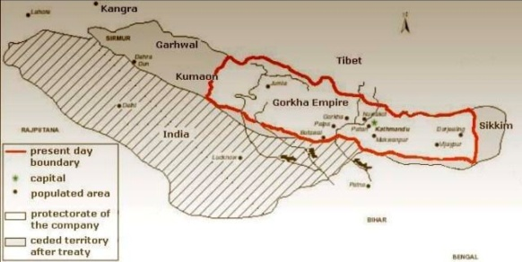
For the British, the Himalayan foothills were not merely a peripheral concern. They represented strategic depth, a buffer against perceived northern threats, and access to lucrative trade routes toward Tibet and beyond. For Nepal, the same terrain was both a shield and a prize: difficult to penetrate, yet essential to maintaining the kingdom’s territorial integrity and prestige. By 1814, the accumulation of skirmishes, diplomatic failures, and mutual suspicion made conflict almost inevitable. When war came, it did so with a degree of confidence on the British side that would soon prove misplaced.
The British plan for the campaign reflected both their strength and their misunderstanding. Confident in their numerical superiority, artillery, and organisational capacity, they conceived a multi-pronged invasion designed to overwhelm Nepalese resistance across a broad front. Several columns were tasked to advance simultaneously through different sectors of the frontier, capturing key positions and forcing a rapid collapse of Nepalese defence. On paper, the plan promised decisive results. In execution, it exposed the limitations of fighting a determined enemy in terrain that negated many of the British advantages.
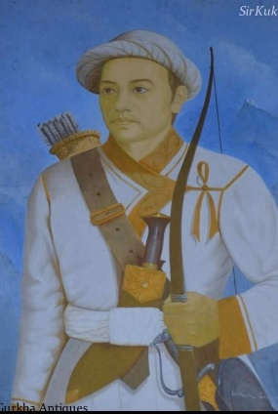
The opening engagements quickly revealed the character of the war. Nowhere was this more evident than at Nalapani, also known as Khalanga, near Dehradun. There, a small Nepalese force under the command of Balbhadra Kunwar occupied a fortified hill position that commanded the surrounding approaches. The British, under Major-General Rollo Gillespie, approached the position with urgency and confidence, expecting a swift victory. Instead, they encountered a defence that was as disciplined as it was resolute.
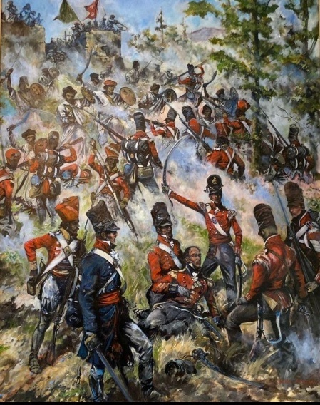
The terrain around Nalapani shaped the battle from the outset. Steep slopes, dense vegetation, and limited avenues of approach channelled the British into predictable axes of advance. The fort itself, though modest in construction, was ideally positioned to exploit these constraints. From elevated positions, the defenders could observe and engage attacking forces long before they reached effective assault range. When the British launched their initial attacks, they did so without fully appreciating either the strength of the position or the determination of its defenders. The result was immediate and costly. Gillespie, leading from the front in a manner consistent with the martial ethos of the time, was killed early in the engagement. His death not only deprived the British of a key commander but also disrupted the cohesion of the assault at a critical moment.
Despite these setbacks, the British persisted with repeated frontal attacks. Each attempt met with fierce resistance. The Gurkhas, fighting from prepared positions and making effective use of both musketry and close combat, inflicted significant casualties. Their discipline under pressure, combined with an evident willingness to fight to the last, began to erode British assumptions about the nature of the enemy they faced. Nalapani was no longer a minor obstacle; it had become a demonstration of the limits of conventional assault tactics in restrictive terrain against a motivated defender.

It was only after these costly failures that the British adapted their approach. Recognising that direct assault would continue to yield disproportionate losses, they shifted to siege tactics. By isolating the fort and, crucially, cutting off its water supply, they transformed the engagement from a contest of arms into a test of endurance. Over time, the effects were decisive. Deprived of water and facing the prospect of annihilation, Balbhadra Kunwar and his remaining fighters made the decision to withdraw. In a disciplined breakout, they abandoned the fort and escaped through British lines, preserving their honour and much of their force. When the British finally occupied Nalapani, they did so not over a defeated enemy, but over a position relinquished only when further resistance became untenable.
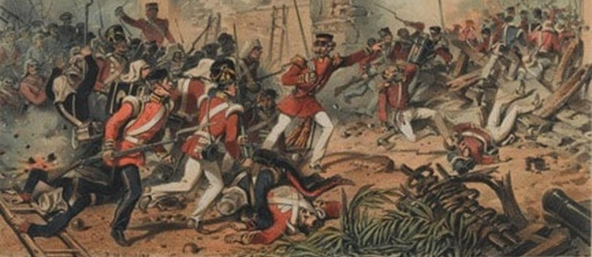
If Nalapani exposed the dangers of underestimating both terrain and opponent, the campaign at Jaithak reinforced these lesson s in a different form. There, Nepalese forces under Ranajor Singh Thapa occupied a high ridge that offered both defensive depth and commanding observation. The British, determined to regain momentum after earlier reverses, attempted a coordinated, multi-axis attack. In theory, such an approach would stretch the defenders and create opportunities for breakthrough. In practice, it demanded precise timing, reliable communication, and mutual support between advancing elements—conditions that were difficult to achieve in the mountainous environment.
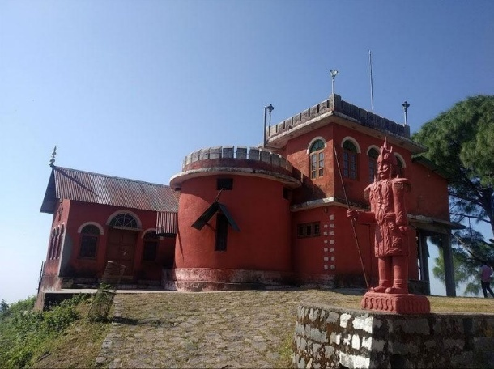
As the attack unfolded, these challenges became apparent. Units advancing along separate routes struggled to maintain synchronisation. Delays on one axis were not effectively communicated to others, leading to fragmentation of effort. Instead of presenting a unified threat, the British forces arrived piecemeal, allowing the defenders to concentrate their response. The Gurkhas, once again exploiting their familiarity with the terrain and their defensive preparation, repelled the assaults and forced a withdrawal. Although the British would eventually secure the position through persistence and reinforcement, the initial failure at Jaithak underscored the critical importance of coordination and the risks inherent in complex manoeuvre under difficult conditions.
While these early engagements highlighted British shortcomings, they also set the conditions for adaptation. In the western theatre of the war, under the command of Sir David Ochterlony, a different approach began to emerge. Ochterlony displayed a level of operational patience and pragmatism that contrasted sharply with earlier efforts. Rather than seeking rapid, decisive engagements through direct assault, he advanced methodically, securing lines of communication, establishing supply bases, and employing artillery in a deliberate and effective manner. His operations demonstrated a clear appreciation of the environment and the enemy, and over time they began to erode the Nepalese defensive system.
This shift in approach marked a turning point in the war. The British, learning from their initial failures, began to apply their advantages in a way that was better suited to the operational context. Logistics were strengthened, coordination improved, and the tempo of operations adjusted to match the realities of the terrain. For the Nepalese, the challenge was different. Their forces had performed with distinction in defensive engagements, but they faced increasing pressure as British operations became more coherent and sustained. The cumulative effect of these operations gradually reduced their ability to hold key positions across the breadth of the front.
By 1816, the strategic situation had shifted decisively. British forces had advanced sufficiently to threaten the heart of Nepal, and the cumulative strain of prolonged conflict, combined with territorial losses, made continued resistance increasingly untenable. The resulting Treaty of Sugauli brought the war to an end. Nepal ceded significant territories, including parts of the Terai and hill regions to the west, and accepted the presence of a British resident in Kathmandu. Crucially, however, Nepal retained its sovereignty, avoiding the fate of many other states that had fallen under direct British control.
In the aftermath of the war, both sides drew important conclusions. For the British, the campaign had been a sobering experience that challenged assumptions about military superiority. The performance of the Gurkhas left a lasting impression, leading to their subsequent recruitment into British service—a relationship that endures to this day. For Nepal, the war reinforced a national identity built on resilience, discipline, and martial tradition. Although territorially diminished, the kingdom emerged with its independence intact and its reputation enhanced.
The Anglo-Nepalese War thus stands as more than a frontier conflict. It is a study in the interaction between strategy, terrain, leadership, and adaptation. It illustrates how initial overconfidence can give way to hard-earned understanding, and how a smaller force, properly led and motivated, can impose significant costs on a larger adversary. Above all, it offers enduring lessons for modern military professionals: that success depends not merely on strength, but on the ability to understand the environment, respect the enemy, and adapt under pressure.
Key Drivers of Conflict
- Disputed borders and unclear territorial control
- Nepalese expansion into Kumaon, Garhwal, and the Terai
- British strategic interest in Himalayan trade routes
- Escalation of frontier clashes without resolution
Operational Reality
- Terrain severely restricted manoeuvre
- Communications and coordination broke down
- British columns operated in isolation
- Gurkhas exploited defensive terrain effectively
4. BATTLE OF NALAPANI (KHALANGA), 1814
The Battle of Nalapani was the opening engagement of the war and a defining moment. A small Nepalese force under Balbhadra Kunwar occupied a fortified hill position overlooking Dehradun.
The British launched immediate frontal assaults, expecting a swift victory. Instead, they encountered disciplined resistance. Major-General Gillespie was killed early, disrupting command and morale. Repeated attacks failed, with heavy casualties.
Recognising the futility of direct assault, the British adapted their approach. They imposed a siege, cutting off the fort’s water supply. After enduring extreme conditions, the Gurkhas conducted a disciplined withdrawal rather than surrender.
Key Observations
- British overconfidence led to tactical failure
- Gurkhas maximised terrain and defensive strength
- Adaptation to siege warfare proved decisive
Lessons
- Avoid frontal assaults without reconnaissance
- Terrain can negate firepower advantage
- Siege and isolation may be more effective than direct engagement
- Leadership resilience is decisive under pressure
5. JAITHAK CAMPAIGN (1814–1815)
Following Nalapani, British forces advanced toward Jaithak, where Nepalese troops under Ranajor Singh Thapa occupied a strong ridge.
The British attempted a coordinated multi-axis assault. However, terrain disrupted synchronisation. Units became fragmented and attacked without mutual support, allowing defenders to repel each effort in detail.

Key Observations
- Poor coordination undermined British operations
- Terrain disrupted timing and communication
- Gurkhas exploited defensive advantage
Lessons
- Synchronisation is critical in multi-axis operations
- Fragmentation leads to defeat in detail
- High ground is a decisive combat multiplier
6. CAMPAIGN TURNING POINT
Under Sir David Ochterlony, the British shifted to a deliberate and methodical approach. He prioritised logistics, coordination, and artillery support, avoiding costly frontal assaults.
- Ochterlony’s Approach
- Phased and deliberate advance
- Strong logistical foundation
- Effective use of artillery
- Avoidance of unnecessary risk
- This marked the turning point in the campaign, gradually eroding Nepalese resistance.

7. END OF WAR (1816)
The war concluded with the Treaty of Sugauli.
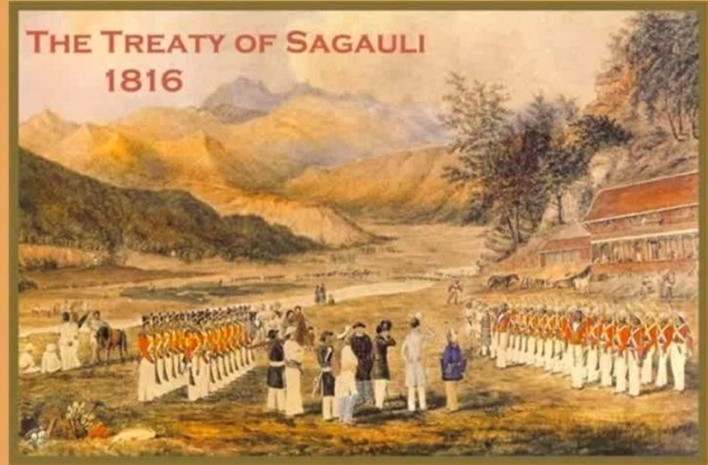
Outcome
- Nepal ceded territory
- British established diplomatic presence
- Nepal retained sovereignty
- Strategic Significance
- Gurkhas gained enduring reputation
- Beginning of Gurkha service in British Army

8. INDIAN MUTINY (1857)
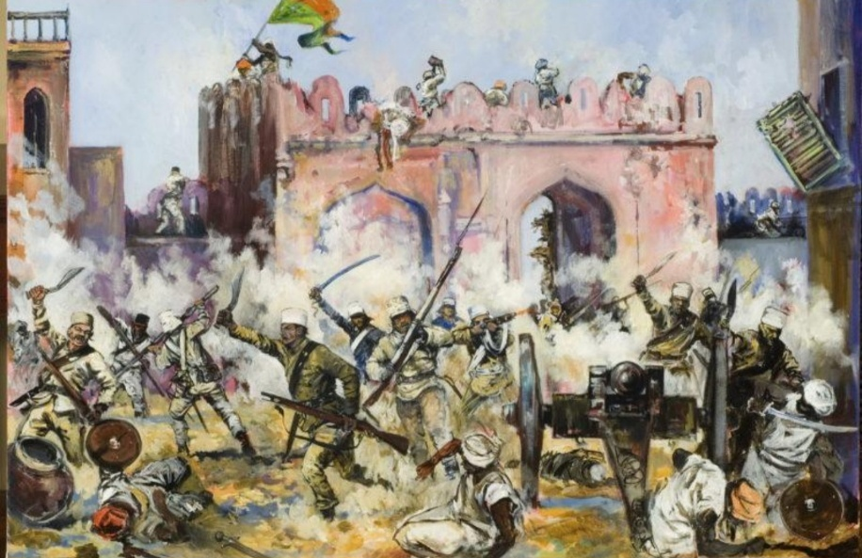
Narrative & Analysis
The Indian Mutiny of 1857 and the Role of the Gurkhas — Narrative Account
The uprising of 1857, often referred to as the Indian Mutiny or the First War of Independence, marked a turning point in the history of British rule in the Indian subcontinent. It began in May 1857 in Meerut, when Indian soldiers serving under the East India Company mutinied against their British officers. What initially appeared to be a military revolt quickly spread into a broader and more complex rebellion across northern and central India, drawing in princes, dispossessed rulers, peasants, and civilians who harboured deep grievances against Company rule.
The causes of the uprising were layered and deeply rooted. Discontent had been growing for years due to British expansionist policies, particularly the annexation of Indian states under doctrines that disregarded traditional succession systems. Economic hardship had intensified under heavy taxation and disruption of local industries. At the same time, social and religious anxieties were heightened by the perception that the British sought to impose their own cultural and religious values upon Indian society. The immediate spark came with the introduction of the new Enfield rifle, whose cartridges were rumoured to be greased with cow and pig fat—offensive to both Hindu and Muslim soldiers—igniting outrage within the ranks.
From Meerut, the rebellion spread rapidly to Delhi, where mutineers proclaimed the aging Mughal emperor as a symbolic leader, transforming the uprising into a political challenge against British authority. Fierce fighting erupted across key centres such as Kanpur and Lucknow, where British forces and civilians found themselves besieged. The scale and intensity of the rebellion placed the British position in India under severe threat.
At this critical juncture, the support of the Gurkhas and the Kingdom of Nepal proved decisive. Relations between the British and Nepal had evolved significantly since the Anglo-Nepalese War, which concluded with the Treaty of Sugauli. Though that war had been hard fought, it had also forged a mutual respect between the two sides, particularly regarding the fighting qualities of the Gurkha soldiers. By 1857, this respect had translated into a pragmatic alliance.
The ruler of Nepal, Jung Bahadur Rana, made a calculated decision to support the British. His motivations were both strategic and political: aiding the British would secure Nepal’s autonomy, strengthen diplomatic ties, and reinforce his own position. Consequently, Nepal committed troops to assist in suppressing the rebellion, while Gurkha regiments already in British service were rapidly deployed to key theatres of war.
Gurkha soldiers quickly distinguished themselves during the campaign. Nowhere was their contribution more evident than in the struggle for Lucknow. The city became one of the central battlegrounds of the conflict, particularly around the Lucknow Residency, where British forces and civilians endured a prolonged and desperate siege. Gurkha troops played a crucial role in both the defence and eventual relief operations. Their discipline under fire, ability to operate in close combat, and unwavering cohesion made them invaluable in the brutal urban fighting that characterised the campaign.
Simultaneously, Gurkha forces were engaged in the wider effort to retake Delhi, the symbolic heart of the rebellion. The siege and recapture of the city were among the most significant operations of the war. Fighting was intense and often conducted at close quarters, requiring troops who could be relied upon to maintain order and aggression under extreme conditions. Gurkha units supported British forces in these operations, contributing to the eventual fall of Delhi and the collapse of organised resistance there.
Beyond these major engagements, Gurkha soldiers were employed across northern India in a variety of roles, from securing lines of communication to conducting offensive operations against rebel strongholds. Their reputation for reliability and effectiveness meant they were often deployed in the most demanding situations. At the same time, the Nepalese army under Jung Bahadur advanced into India, reinforcing British efforts and helping to stabilise areas that might otherwise have remained contested.
By 1858, the rebellion had been largely suppressed. The aftermath brought profound changes. The rule of the East India Company was abolished, and authority over India was transferred directly to the British Crown, marking the beginning of the British Raj. The structure of the Indian Army was also fundamentally reorganised, with greater emphasis placed on recruiting from groups considered loyal during the uprising—among them the Gurkhas.
For the Gurkhas, the events of 1857 were transformative. Their steadfast service during the conflict cemented their reputation as elite soldiers within the British military system. In the years that followed, Gurkha regiments expanded and became a permanent and distinguished component of what would eventually be formalised as the Brigade of Gurkhas. Their legacy of loyalty, courage, and professionalism, demonstrated so clearly during the crisis of 1857, continued to define their role in subsequent conflicts across the world.
In essence, the Indian Mutiny was not only a conclusive struggle over power and governance in India, but also a defining moment in the military partnership between Britain and Nepal. The contribution of the Gurkhas during this turbulent period helped shape both the outcome of the rebellion and the enduring bond between the two nations’ armed forces.
Key Causes
- Cultural and religious insensitivity
- Economic exploitation
- Political annexation policies
Lessons
- Cultural awareness is critical
- Insider threat can destabilise operations
- Urban warfare is complex and resource-intensive
- Information and legitimacy are decisive
9. RED FORT, DELHI
The Red Fort, built by Shah Jahan, served as the symbolic centre of Mughal authority and the focal point of the 1857 rebellion.
- Military Significance
- Strategic command location
- Symbol of political legitimacy
Lesson
Control of symbolic terrain influences both morale and strategic outcomes.

10. TAJ MAHAL, AGRA
The Taj Mahal, also built by Shah Jahan, represents the height of Mughal cultural and architectural achievement.
While not a battlefield, it reflects the broader context of imperial power.
Strategic Insight
- Cultural influence reinforces political authority
- Power is expressed beyond military capability

11. CROSS-CUTTING LESSONS
Tactical
- Terrain dominates outcomes
- Defensive positions multiply combat power
Operational
- Logistics underpin success
- Coordination and timing are critical
Strategic
- Cultural awareness prevents conflict escalation
- Symbolic centres shape legitimacy
Leadership
- Resilience under pressure
- Adaptability and sound judgement
12. SYNDICATE DISCUSSION QUESTIONS
- Why did British forces initially fail at Nalapani?
- How does terrain influence modern operations?
- Could the Indian Mutiny have been prevented?
- What is the importance of symbolic terrain today?
- Which leadership traits were most decisive?

13. CONCLUSION
This battlefield study reinforces that:
Warfare is as much about people and perception as it is about manoeuvre and firepower. Understanding the human dimension – both within one’s own forces and among the local population – remains essential to achieving lasting outcomes.
In summary, this battlefield study is not simply a reflection on history, but a professional tool to inform present and future operations. The lessons identified – leadership, resilience, adaptability, and contextual understanding must be carried forward and applied with rigour. The battlefield may belong to the past, but their lessons remain directly relevant to the challenges faced by today’s military professionals

EX PURKHA KO PAURAKH
Master Events List (MEL)
Period: 05 – 17 May 2026
Location: Nepal – India (Delhi / Dehradun / Agra)

05 May 2026 – Syndicate Preparation
Time | Event | Activity | Lead | Remarks
1330 | Opening Brief | Exercise overview/Admin | SO3G2/3/6 | Ex MEL, Updates on Visas
1345 | Syndicate Work | Research & refinement | Syndicate Leads | Based on the battle of Jaithak
1600 | Presentation Prep | Develop briefs | Syndicates | 5 min each – Syndicate A&B
1630 | Back brief | Present findings | All

07 May 2026 – National Museum Visit
Time | Event | Activity | Lead | Remarks
0830 | Depart BGN | Move to Museum | RQMS | Memento – prep and presented to Museum by senior BGN Officer.
0900 | Museum Visit | Historical familiarisation | SMEs
1230 | Lunch | Local Area | RQMS | Cost – individual payment
1400 | Return | Move to Camp | RQMS
1430 | Hot Wash-Up | Lessons discussion | SO3G2/3/6

10 May 2026 – Deployment
Time | Event | Activity | Lead | Remarks
0630 | Muster | Final checks | RQMS
0700 | Flight KTM–Delhi | Air move | All | Check In
1150 | Arrive Delhi | Immigration | SO3G2/3/6
1300 | Meet DComd | Delhi Airport | SO3G2/3/6
1330 | Road Move | Delhi–Dehradun | RQMS | Mini-bus  Local hire
1500 | Lunch | Local Services | FSA | Collective payment/Cash/ Card
1830 | Arrive Dehradun | Hotel check-in | Admin | Hyatt Centric

11 May 2026 – Khalanga Orientation
Time | Event | Activity | Lead | Remarks
0830 | Depart | Move to Khalanga | RQMS
0900 | Visit | Site observation and study | Historian | In presence of the president of Khalanga memorial committee and the members.  BGN plaque to be handed over to the president (Retd Col B Thapa) by DComd – RQMS to prepare
1130 | Discussion | Battlefield context | SO2G2/3/6 | Historian and all BFS participants
1330 | Lunch | Hotel | FSA | Cash/ Card payment
1500–1700 | Pacific Mall Visit | Admin time | Interested | Pacific mall is adjacent to the Hotel
1800–1900 | Debrief | Lessons/next day | SO3 G2/3/6 | All

12 May 2026 – Nalapani Study
Time | Event | Activity | Lead | Remarks
0830 | Depart Hotel | Move to site | RQMS | Appropriate clothing and walking gear.
0900 | Study | Nalapani analysis | Historian | All
1300 | Lunch | At hotel | FSA | Cash/ Card payment for all
1300 | Self-Study | Reflection | All
1800 | Engagement | AWC visit | AWO Dehradun | All to attend.  Light Dinner will be served at AWC.  Dress: Smart Cas/ BGN Tie  Opportunity to engage with veterans  BGN plaque to be handed over to AWO by DComd – RQMS to prepare

13 May 2026 – Jaithak Study
Time | Event | Activity | Lead | Remarks
0830 | Depart | Move to site | RQMS | Road move  2 hrs
1100 | Study | Site analysis | Historian
1330 | Lunch | Local Area | FSA | Payment by Cash for all
1430 | Depart | Road Move | RQMS | Return to hotel
1800 | Dinner | At hotel | FSA | Payment by Cash/ Card for all
1830 | Debrief | Lessons | Historian/ SO3 G2/3/6

14 May 2026 – Transit
Time | Event | Activity | Lead | Remarks
0900 | Depart | Road move to Delhi from Dehradun | RQMS | Check out/ Clear outstanding bills.
1500 | Arrive | Check-in | All | Cannaught hotel- Old Delhi

15 May 2026 – Taj Mahal
Time | Event | Activity | Lead | Remarks
0900 | Depart | Delhi – Agra | RQMS | Road move
1200 | Visit | Cultural study | All
1430 | Lunch | Local Area | FSA | Payment by Cash for all
1530 | Depart | Agra – Delhi | RQMS
1900 | Dinner | Hotel | FSA | Payment by Cash/Card for all

16 May 2026 – Delhi Study
Time | Event | Activity | Lead | Remarks
0900 | Site Visits | Red Fort/Indian mutiny park | Historian | Site entry fee – individual payment
1330 | Lunch | Local Area | FSA | Payment by cash for all
1400 | Cultural Visit | Chandni Chowk | All | Shopping opportunity
1800 | Final Debrief | Summary | Historian/ SO3G2/3/6

17 May 2026 – Redeployment
Time | Event | Activity | Lead | Remarks
0730 | Depart Hotel | To Airport | RQMS
1135 | Flight | Delhi–KTM | MCC
1230 | Arrive KTM | End Ex | All | Transport – AMTO

References:
Buchanan-Hamilton, F. (1819) An account of the kingdom of Nepal. Edinburgh: Archibald Constable.
Farwell, B. (1984) The Gurkhas. London: W.W. Norton & Company.
Gardner, E. (1816) Sketch of the war between the British Government in India and the Goorkhas. Calcutta: Government Press.
Kirkpatrick, W. (1811) An account of the kingdom of Nepaul. London: William Miller.
Whelpton, J. (2005) A history of Nepal. Cambridge: Cambridge University Press.
Wright, D. (1877) History of Nepal. Cambridge: Cambridge University Press.
Young, P. (1971) The Anglo-Nepalese War 1814–1816. London: Osprey Publishing.
British Library (n.d.) Anglo-Nepalese War: India Office Records and archives. Available at: https://www.bl.uk⁠� (Accessed: 20 April 2026).
Gurkha Museum (n.d.) History of the Gurkhas and Anglo-Nepal War archives. Available at: https://thegurkhamuseum.co.uk⁠� (Accessed: 20 April 2026).
National Army Museum (n.d.) Anglo-Nepal War 1814–1816. Available at: https://www.nam.ac.uk⁠� (Accessed: 20 April 2026).
Encyclopaedia Britannica (n.d.) Anglo-Nepalese War. Available at: https://www.britannica.com⁠� (Accessed: 20 April 2026).
JSTOR (n.d.) Scholarly articles on the Anglo-Nepal War. Available at: https://www.jstor.org⁠� (Accessed: 20 April 2026).
Google Scholar (n.d.) Search: Anglo-Nepal War 1814 research papers. Available at: https://scholar.google.com⁠� (Accessed: 20 April 2026).
Internet Archive (n.d.) Primary sources: Anglo-Nepal War texts and historical books. Available at: https://archive.org⁠� (Accessed: 20 April 2026).
The Last Mughal: The Fall of a Dynasty, Delhi, 1857 by William Dalrymple (utilizes material from the National Archives of India).
Besieged: Voices from Delhi 1857 by Mahmood Farooqui (translations of primary documents).

